DRAFT Minutes of the Little Hoole Parish Council Meeting  held on Monday 10th Feb 2025, at Walmer Bridge Village Hall  In attendance: Cllrs L Dryden (Chair), P Ashby, S Evald, D Owen, T Wilcock, J Rainsbury. Mr P Cafferkey (Clerk & Responsible Financial Officer); and 3 members of the public. | 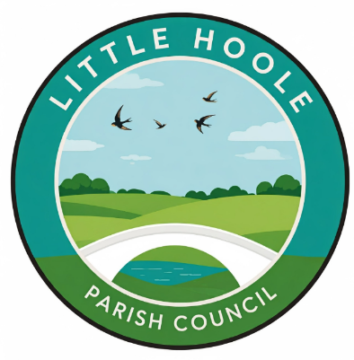
- Apologies for absence: Cllr S Rainsbury.
- To agree the minutes of the last Parish Council mtg: The minutes of the Parish Council meeting held on 13th Jan 2025, were accepted as a true record and agreed unanimously.
- To receive declarations of interest: None
- Matters arising from the minutes of last meeting: None.
- Public Time - matters raised by members of the public: A member of the public enquired again as to as to progress regarding the reinstatement of an inspection chamber at the corner of Tristan Avenue and Dob Lane. The Chair confirmed that he has made enquiries and has been informed that the utility company responsible is to be fined for late completion of this work. Two members of the Walmer Bridge Village Hall Committee were present and explained their request for a grant of £4,718 to purchase two professional marquees to replace existing marquees which are no longer usable. The replacement marquees are required to enable WBVH to cater for large events, any monies raised by these events go to towards the upkeep of WBVH. Section 6 also refers.
- Grant Application from WBVH. It was resolved that agreement in principle be given for the Parish Council to purchase two marquees on behalf of WBVH so that the Parish Council can reclaim the VAT and then gift the marquees to WBVH. The representatives were asked to obtain three quotes and also to explore the cost of the marquees being branded with wording along the lines of “Funded by Little Hoole Parish Council”.

- Planning Applications:
- 07/2024/00950/HOH. The Mill 47 Jubilee Road Walmer Bridge PR4 5QW. Single storey side extension to include chimney together with the repositioning of the existing boundary wall closer to the highway (amended description)
- 07/2024/00889/FUL. Carver Hey Farm Moss Lane Little Hoole PR4 4SX. Demolition of Existing Buildings and Erection of 9 Detached Dwelling
There were no objections to the planning application at a) above. As regards item b) above it was agreed that the Parish Council would write to the Planning Authority (SRBC) to seek clarification on a number of issues.

- Payments for approval: It was resolved that the Clerk’s claim for Jan 2025 of 12.90 hours be approved.

- Payments approved by email or pre-approved and retrospectively noted: It was resolved that the purchase of replacement defibrillator pads at a cost of £79.20 (incl VAT) be retrospectively approved.
- Gifting of Lawnmower to Hoole Bowling Club. It was resolved to ratify a previous decision of the Parish Council to gift the purchase of a lawnmower at cost of £5,100 (incl of VAT), jointly funded by Little Hoole Parish Council and Much Hoole Parish Council, to Hoole Bowling Club.
- Grant to Little Hoole Primary School PTA – Update. The Clerk informed the Parish Council that the grant of £2,000 for replacement of line markings on one of the school’s playgrounds had now been paid.
- Standing Orders & Financial Regulations. It was resolved that these be re-approved; no changes were considered necessary.
- HR Policies. It was resolved that these policies be re-approved; no changes were considered necessary. The policies concerned are Sickness Policy, Disciplinary Policy, Grievance Policy, Performance Improvement Policy, and Equality, Diversity & Inclusion Policy.
- Lancashire Best Kept Village Competition. It was resolved that the Parish Council would not be entering this year’s competition.
- Community Orchard. It was resolved that the Parish Council would apply for a Community Orchard grant available from Lancashire County Council, for the planting of orchard trees on Dob Lane Recreation Park. Cllr Wilcock kindly agreed to complete the application and arrange for the planting of the trees.
- Zip Wire Project Update. Cllr Evald confirmed that work will commence on 3 March 2025.
- Adoption of .gov.uk email addresses for all Parish Councillors. It was resolved that the Parish Council would adopt .gov.uk email addresses at an annual cost of £191.40 (excl VAT).
- Information and Updates: This item is purposefully not recorded; it is to allow Councillors a short time to discuss any matters that might result in a future agenda item. No financial or legal decisions are made.
- Correspondence: The Clerk reported that he had received an email from a resident concerned about dog fouling in the village. The resident has contacted SRBC and the Clerk has kindly requested he be kept informed as to SRBC’s response.
- Date & Time of Next Meeting: It was agreed that the next meeting is to be held on the 10th Mar, 2025, 7.00pm, The Lounge, Walmer Bridge Village Hall.

